1. Create a user

a. with a home directory

b. with tcsh as the default shell

c. with “Temp” in the comment field

d. with user id

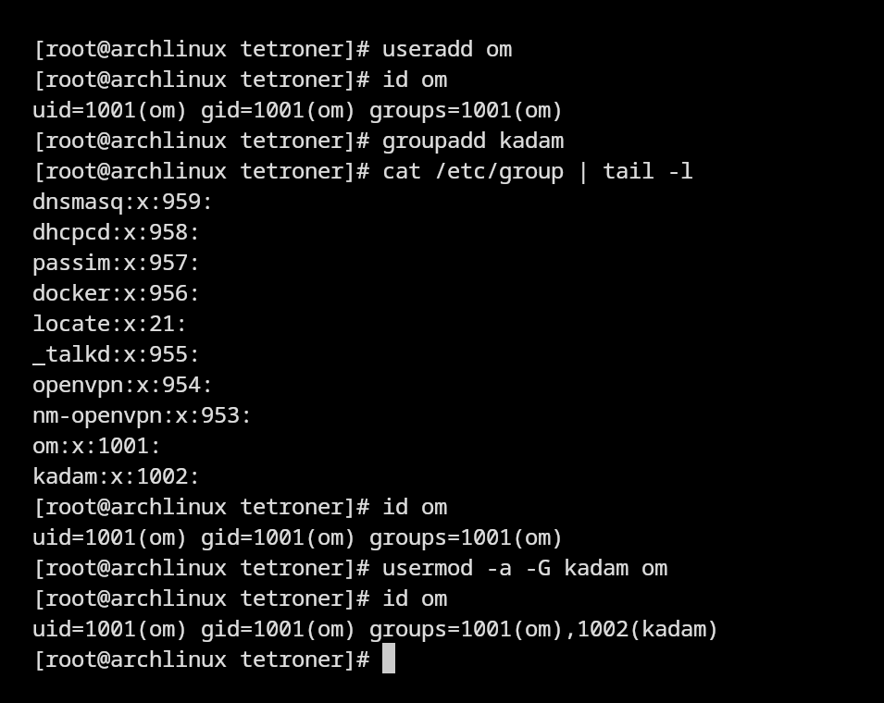

2. Create a user by assigning the primary group explicitly.

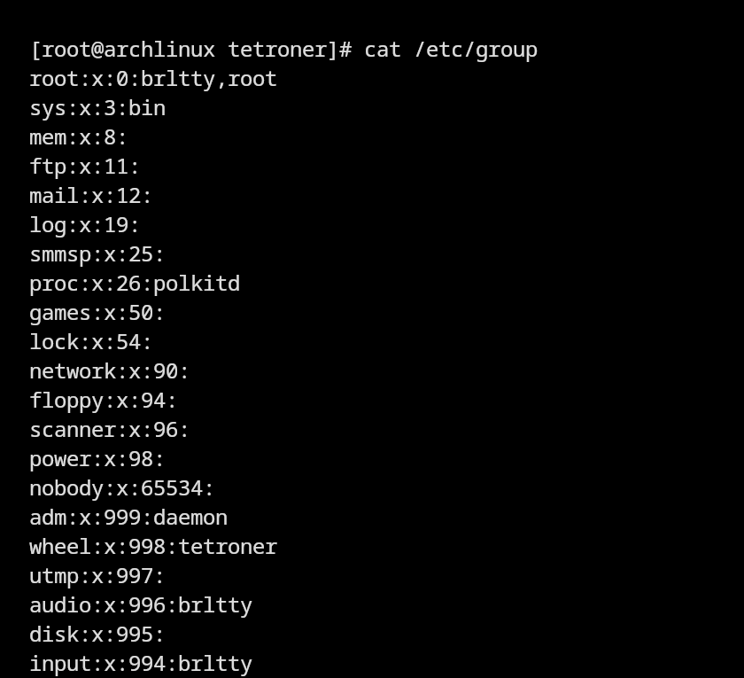

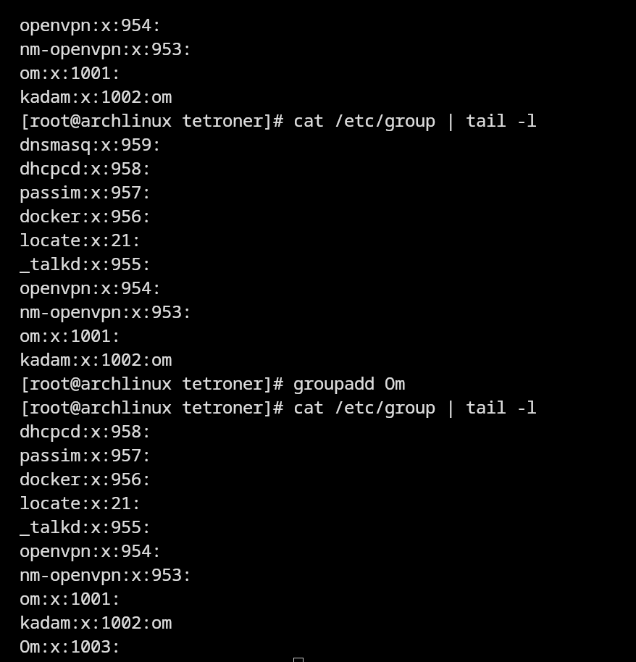

3. Demonstrate the account status using the password aging settings and infer on

the various account status.

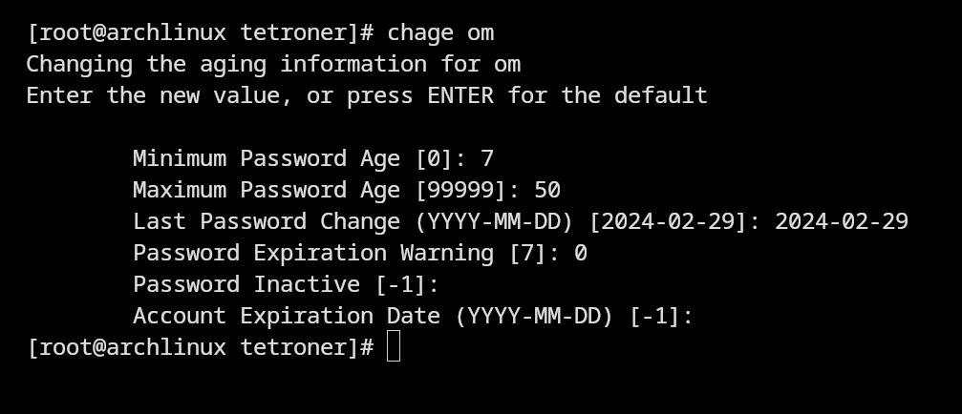

4. Demonstrate locking and unlocking of the user password

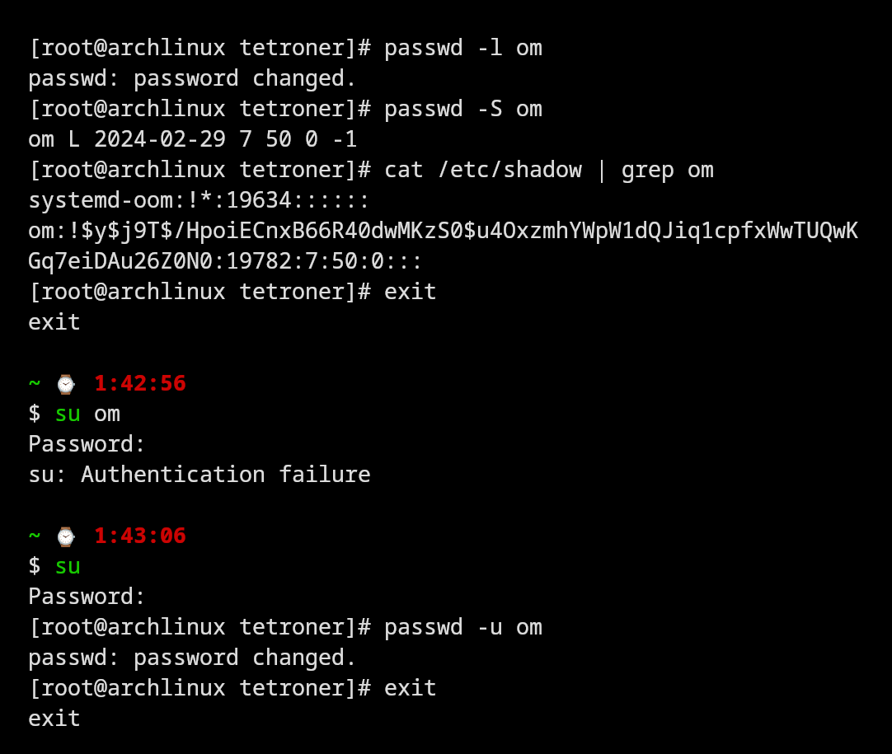

5. Demonstrate aging setting of password for permanent and periodic passwords

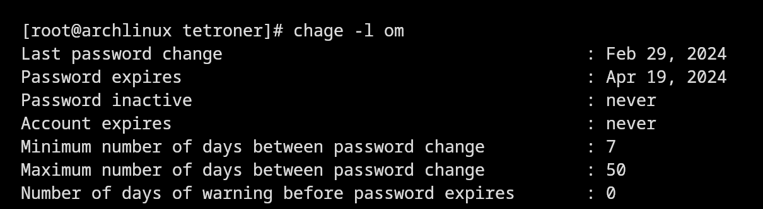

6. Change the existing primary group of the user.

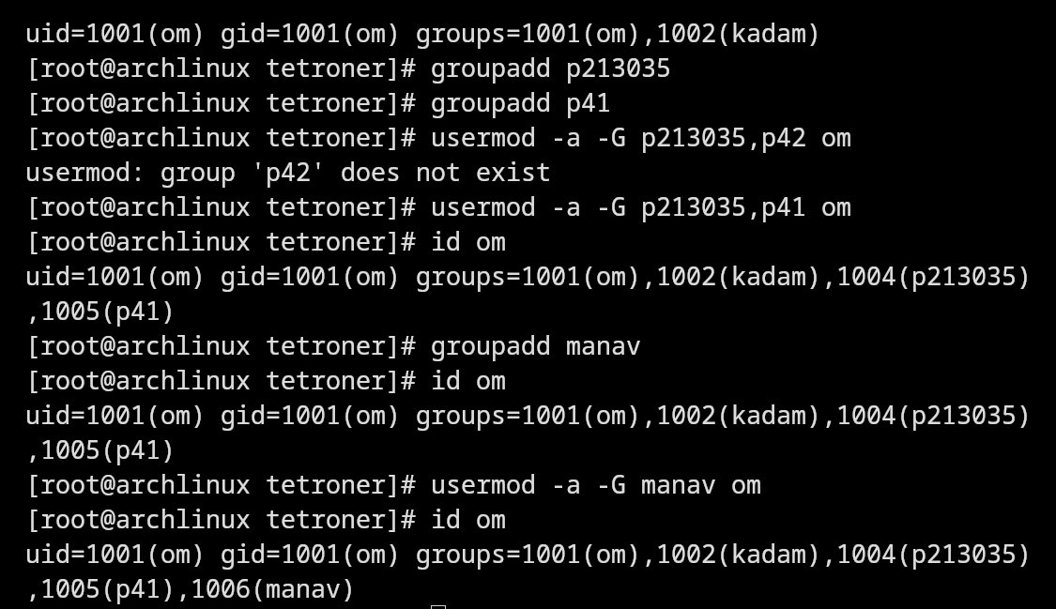

7. Add the user to existing supplementary group



8. Perform following file operations:

a. Create a text file. Infer the file permissions.

b. Using Octal mode change the permission on a particular file as rw-rw-r

c. Using Symbolic mode change permission on a particular file as rw-rw-r–

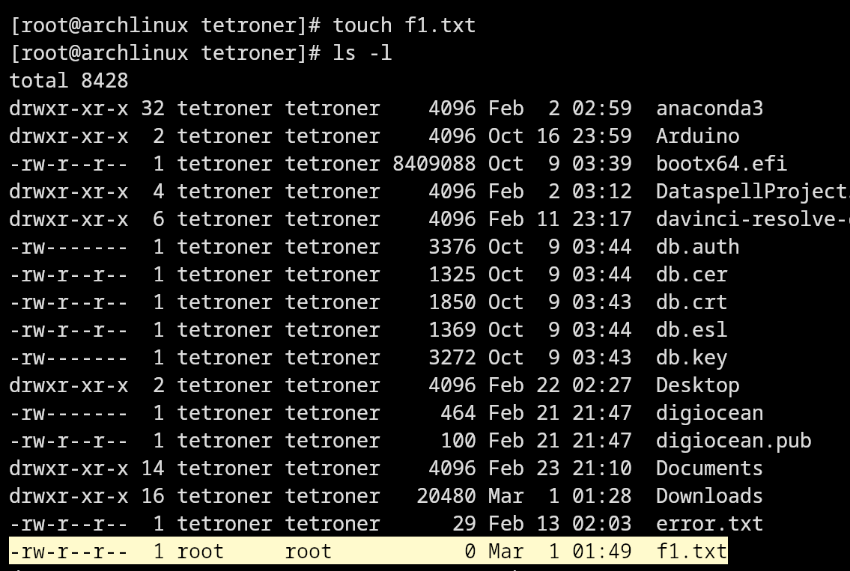

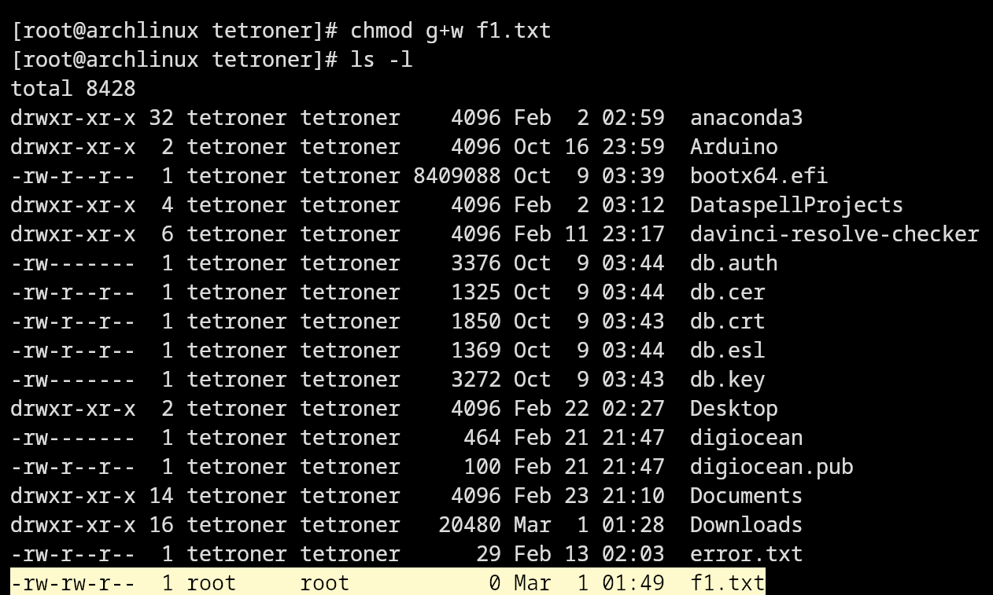

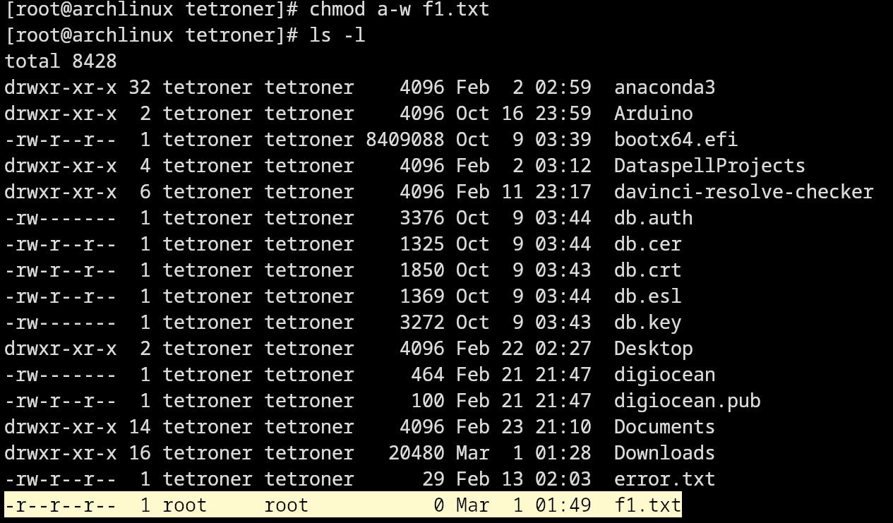

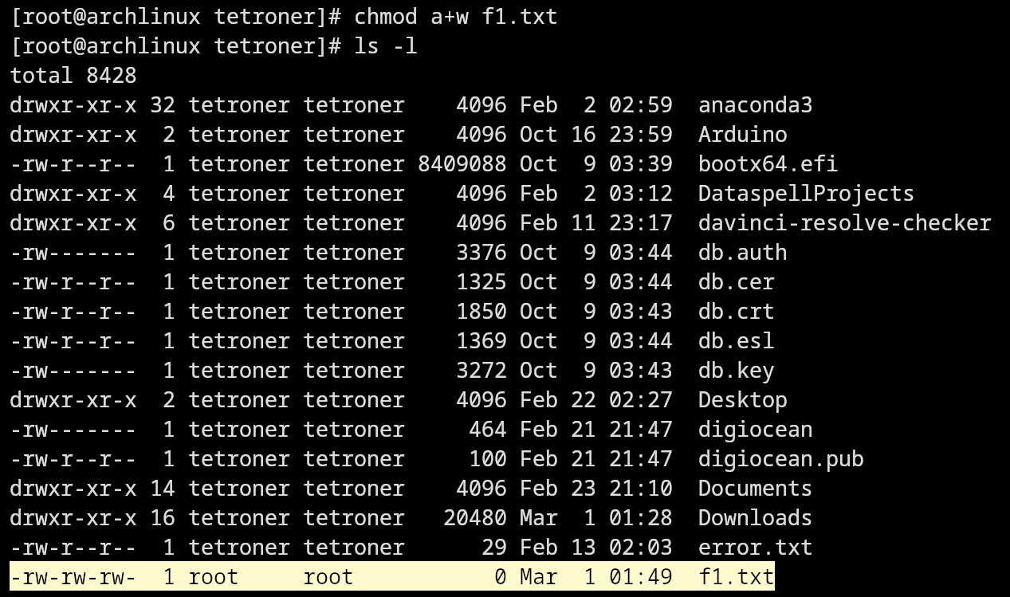

9. Demonstrate changing file ownership using chown command.

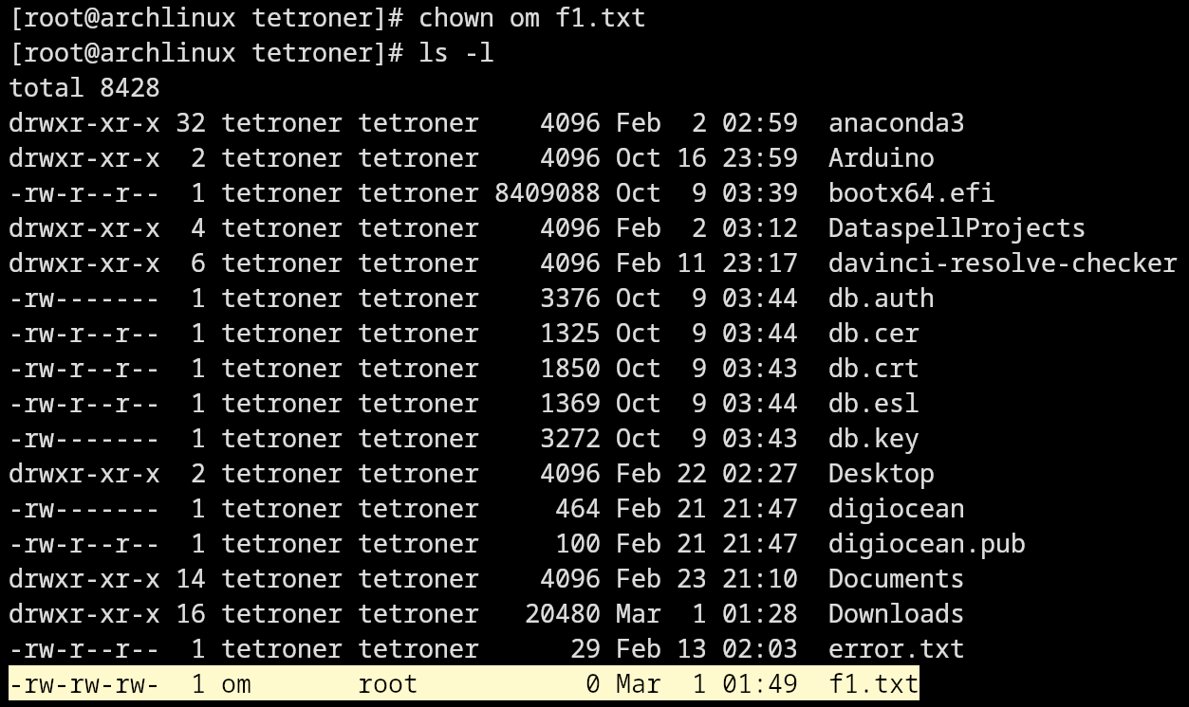

10.Create a file & share between multiple users (all users must be able to rwx file).

